**NAME : MIRTUNJAY KUMAR**

**REG NO:16BCE1179**

**PROF:VISHNU PRIYA**

**TOPIC :FUNCTION**

**CREATING TABLE FIRST AND INSERTING VALUES IN IT:**

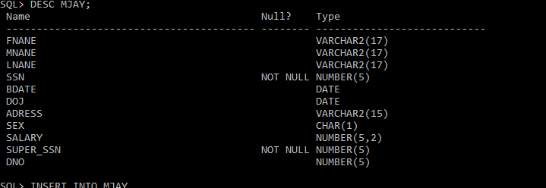

**VALUES INSERTED:**

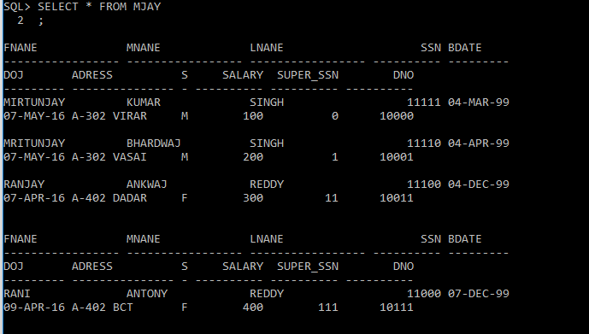

**Built in functions, order by, group by and logical functions**

**Character functions**

Sql> select initcap(‘xyz’) from MJAY;

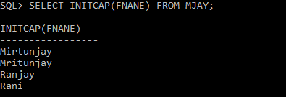

Sql> select lower(‘XYZ’) from MJAY;

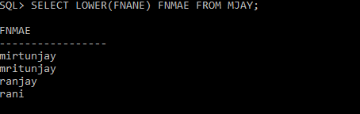

Sql> select upper(‘xyz’) from MJAY;

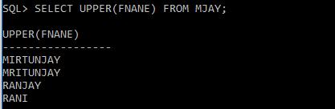

Sql> select ascii(‘a’) from MJAY;

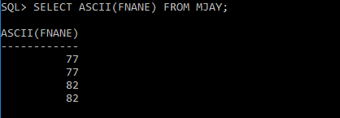

Sql> select rtrim(‘MIRTUNJAY’,’JAY’) from MJAY;

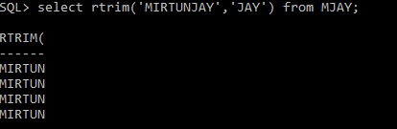

Sql> select ltrim(‘MIRTUNJAY’,’MIR’) from MJAY;

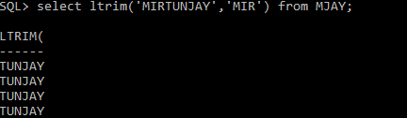

Sql> select translate(FNANE,’Y’,’K’) from MJAY;

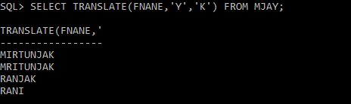

Sql> select lpad(FNANE,4,’*’) from MJAY;



Sql> select rpad(FNANE,3,’*’) from MJAY;

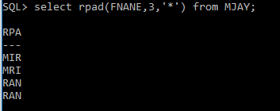

Sql> select instr(FNANE,’Y’) from MJAY;

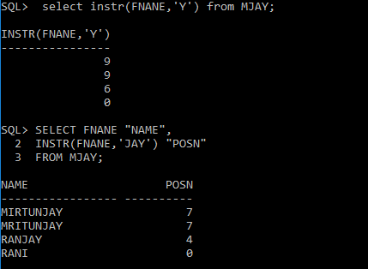

Sql> select FNANE,LENGTH(FNANE) AS LEN from MJAY;

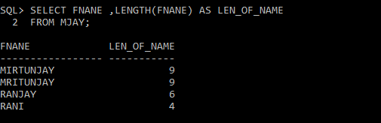

**Numeric functions**

Sql>; select abs(SALARY) from MJAY

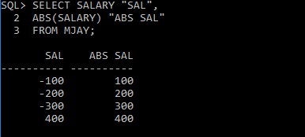

Sql> select abs(DNO) from MJAY;

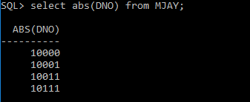

Sql> select ceil(SALARY) from MJAY;

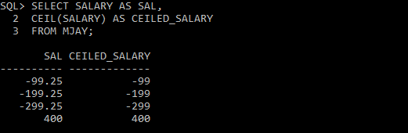

Sql> select floor(SALARY) from MJAY;

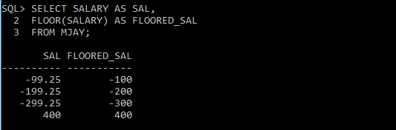

Sql> select power(SALARY,2) from MJAY;

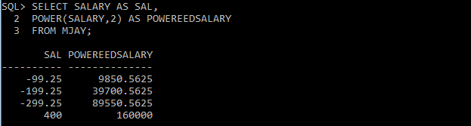

Sql> Select mod(10,3) from MJAY;

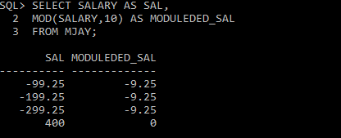

Sql> select sqrt(25) from MJAY;

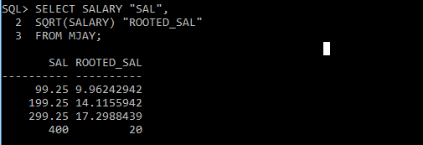

Sql> select trunc(100.43) from MJAY;

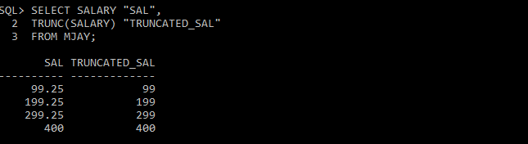

Sql> select round(SALARY) from MJAY;

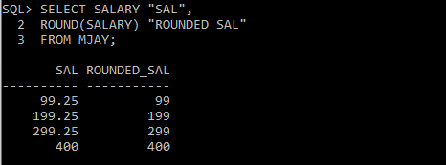

Sql> Select sign(-34) from MJAY;

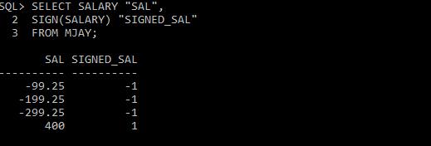

Sql> Select sign(34) from MJAY;

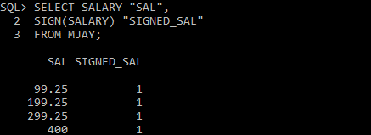

**Date functions**

Sql> select to_char(DOJ,’dd-mm-yyyy’) from MJAY;



Sql> select add_months(sysdate,9) from MJAY;



Sql> select months_between(’07-aug-05’,sysdate) from MJAY;

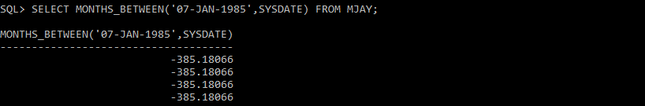

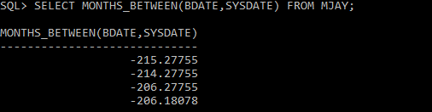

Sql> select greatest(’17-jun-00’,sysdate) from MJAY;



Sql> select next_day(’03-jun-08’,’wed’) from MJAY;

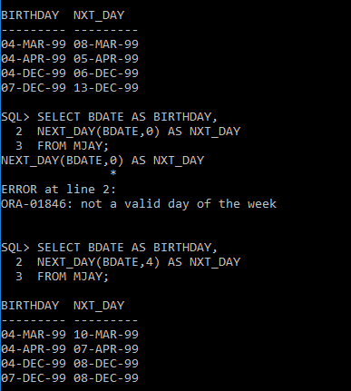

Sql> Select last_day(sysdate) from MJAY;

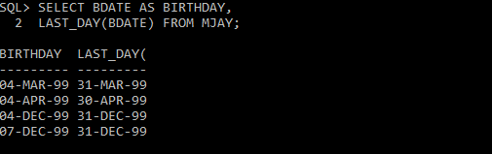

Sql> select trunc(to_date(‘03-jun-08’),’year’) from MJAY;

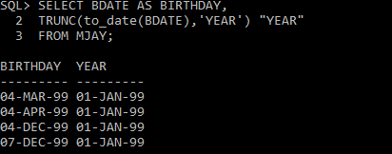

Sql> select last_day(sysdate) from MJAY;

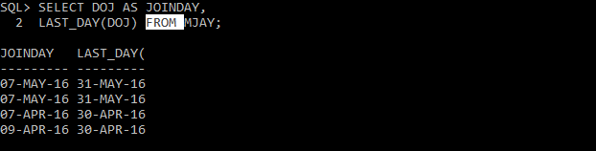

**Group by functions:**

1. Count
2. avg
3. max/min
4. sum

**SYNTAX**

**Count: TO COUNT NO OF RECORDS**

Sql> select count(*) from tablename;

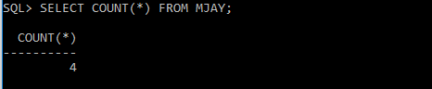

Sql> select count(distinct columnname) from table name

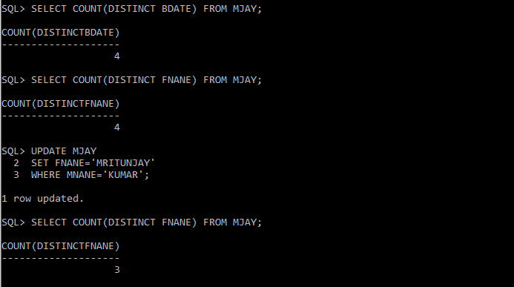

**AVG: TO FIND AVERAGE VALUE FROM THAT COLUMN**

Sql> select avg(columnname)from tablename;

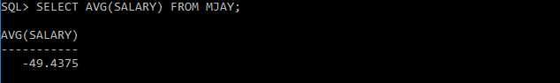

**MAX/MIN VALUE FROM THAT COLUMN:**

Sql> select max(columnname)from tablename

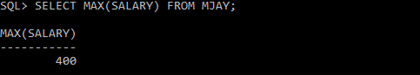

Sql> select min(columnname)from tablename

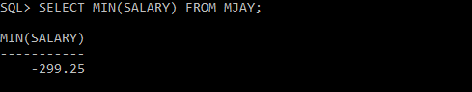

**SUM: SUM OF ALL VALUES FROM THAT COLUMN**

Sql> select SUM(column name) from tablename

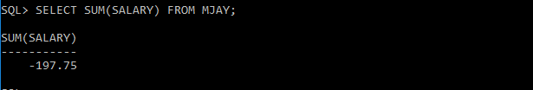

**Group by Clause:**

Sql> select columnname from tablename groupby columnname

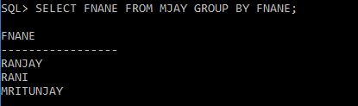

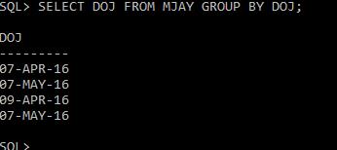

**Order by functions:**

**1.ASC (ASCENDING ORDER)**

**2.DESC (DESCENDING ORDER)**

Sql> select columnname from tablename where condition orderby columnname

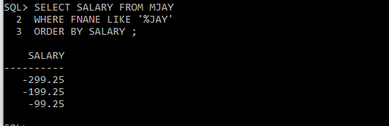

Sql> select columnname from tablename where condition orderby desc,columnname

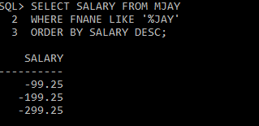

Sql> select columnname from tablename where condition orderby asc,columnname

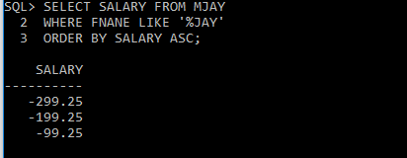

Sql>select colname from tablename order by colunmname desc;

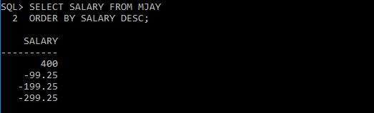

Sql>select colname from tablename order by colunmname asc;

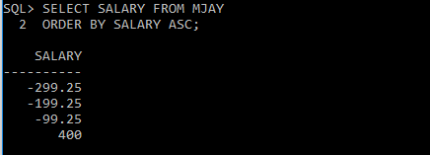

**LOGICAL FUNCTIONS**:

1. ALL RELATIONAL OPERATORS (<,>,=,<>)
2. LIKE,NOT LIKE,IS NULL, IS NOT NULL,IN, NOT IN,BETWEEN,NOT BETWEEN

SYNTAX:

sql> select colname from tablename where colname like(‘mo%’)

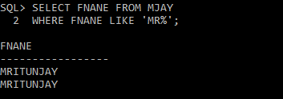

sql> select colname from tablename where colname not like(‘mo%’)

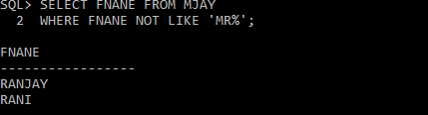

sql>select *from tablename wherer columnname is null

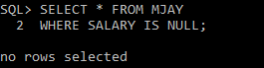

sql>select *from tablename where columnname is not null

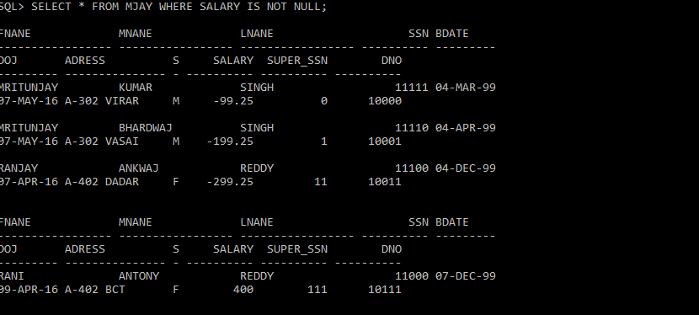

sql>select *from tablename where columnname in( value1,value2,..valuen.)

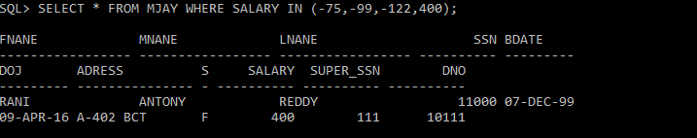

sql>select *from tablename where columnname not in( value1,value2,..valueN.)

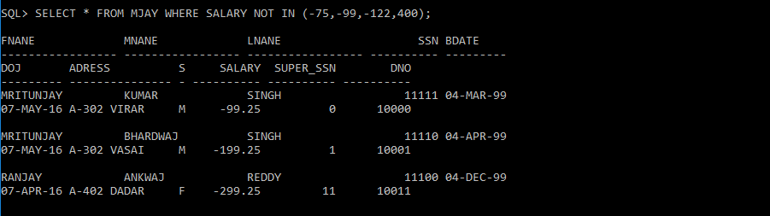

sql>select *from tablename where columnname between(value1and value2)

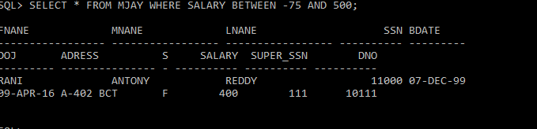

sql>select *from tablename where columnname not between(value1 and value2)

